# Objective

To practice using fundamental Processing commands so that these methods become second nature to writing more advanced code.

## Topics: method calling, coordinate system

# Instructions

Using your fundamental knowledge of Processing, draw a smiley face on a window that is 800 x 600. Your smiley face should be centered on the screen. You may choose the colors and sizes of the smiley face you draw, but it should include two eyes, one nose and a mouth. Save the sketch as “YourNameSmileyFace”

# Examples

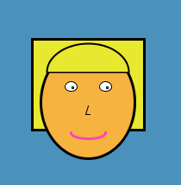

# Hints

Sometimes Processing does not have the exact shape we need. Use combinations of shapes that overlap to get the effect you need. For example, the following code:

fill(0);  
ellipse(200,250,200,200);  
noStroke();  
fill(255);  
ellipse(200,200,200,200);



Will draw a black circle then a white circle on top to give the appearance of a smile:

# Challenge

Use the technique from the Hint section to add shading to your Smiley Face and give it a more three dimensional look.